Issue 167 | July 2025

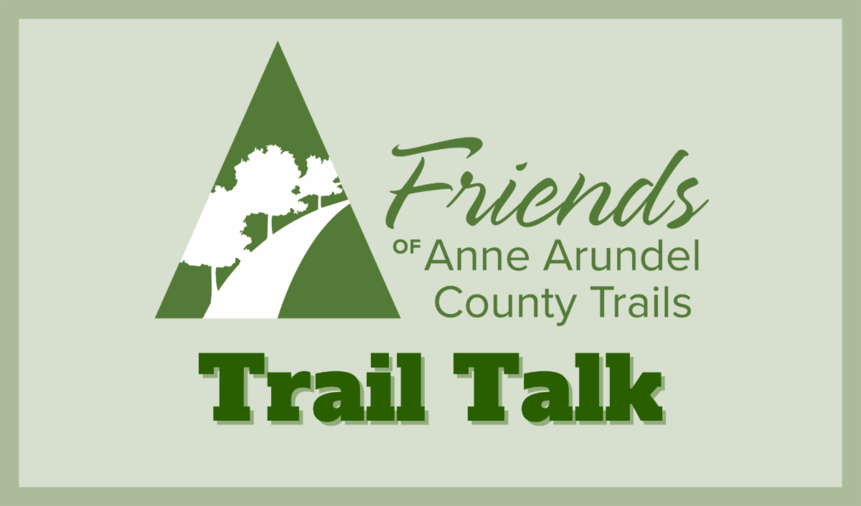

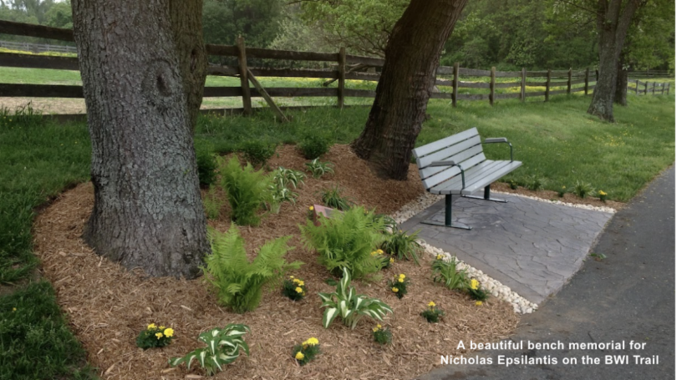

Upcoming Events



  Sunday, July 20, 2025
  9am - 11am
  Lemonade Stand Fundraiser for Local Boy with Cancer
  ﻿
  The Friends will be doing a Meet & Greet on the B&A Trail at the Earleigh Heights Ranger Station. Learn all about the Friends of Anne Arundel County Trails and support Clyde Hicks, a young boy who is battling cancer, by buying a cold cup of lemonade. Clyde's baseball team is teaming up with the Friends to support Clyde and his family. Please stop by!
  51 W Earleigh Heights Rd, Severna Park, MD 21146
  

Trail Highlights

  Honor Your Loved Ones with a Gift that Lasts
  A Lasting Gift is a beautiful way to honor a dear friend, a family member, or someone special while enhancing the trails for Anne Arundel County. We offer engraved bricks for people and pets, bulletin boards, and benches. There are several old benches that need to be replaced along the B&A Trail north of Earleigh Heights Ranger Station. The cost is $3000 and includes the bench, installation, and a bronze plaque.
  The purchase of a Lasting Gift through the Friends of Anne Arundel County Trails is tax deductible to the fullest extent of the law. For a list of available bench locations, please contact us at: friendsofaatrails@gmail.com
  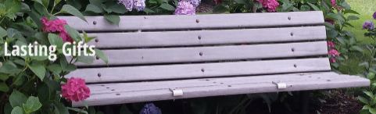
  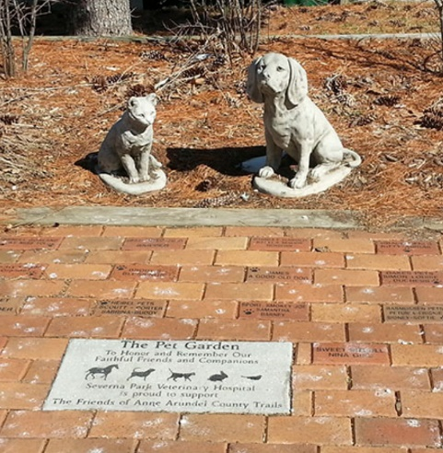
  Lasting Gifts

~Art on the Trails~

Head out there and discover the hidden gems along our beloved trails!

  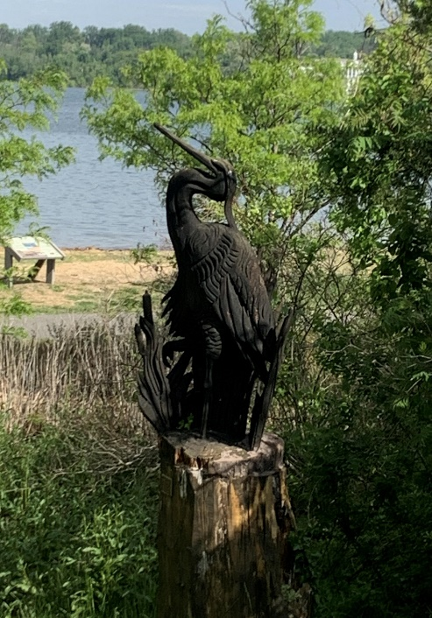
  Located at Jonas and Anne Catharine Green, this intricate chainsaw statue of a heron was created in honor of James E. Wanko by his family in 2015.
  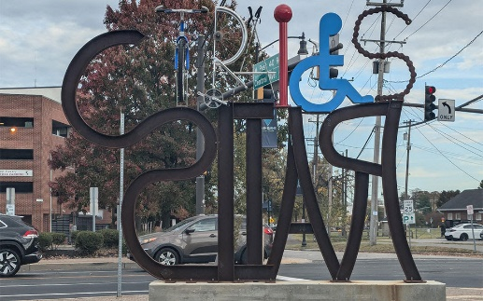
  The Rails to Trails sculpture stands in a pocket park at the Glen Burnie Town Center, marking the site of a former rail depot. The sculpture was commissioned by the Arts Council of Anne Arundel County in 2023, and was created by local artist James O'Neil.

  In case you missed it...
  A Must-Visit Little Museum for Odenton Residents and History Buffs Alike
  With the WB&A trail connection completed, there's no better time to take a trip up to the northern terminus of the trail where, on the first Sunday of every month from 1-4pm, the Odenton Heritage Society is open for visitors.
  See unique artifacts, view photographs, and speak to docents with extensive knowledge of the area's history, especially as several have lived it themselves! Admission is free and the building is easily accessible by crossing over Piney Orchard Pkwy at Odenton Rd. Link corrected below:
  Museum Official Site
  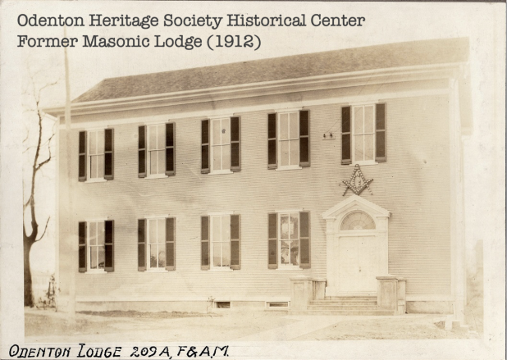
  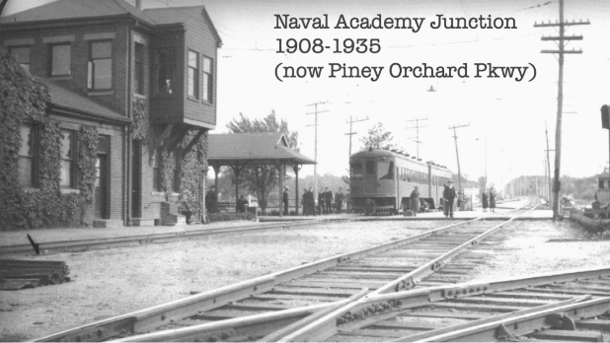
  Odenton Heritage Society Historical Center
  1367 Odenton Road
  Odenton, Maryland 21113

Volunteer News

  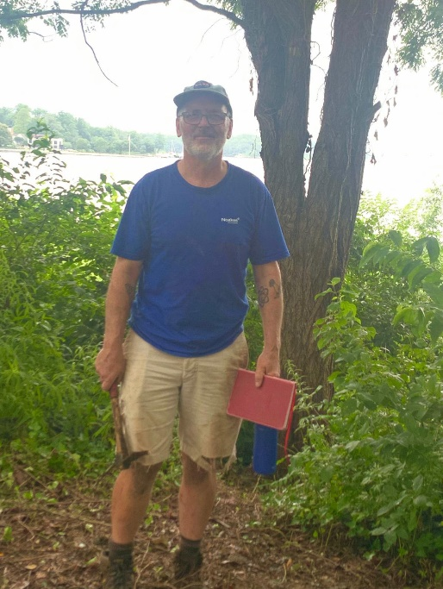
  Outstanding Volunteer Feature
  Mike Meinhold
  Flowerbed Volunteer
  Mike took up his responsibilities at Jonas and Catharine Green only recently, but has already made a huge impact on the park... and on us!
  "I grew up on Long Island, NY, the son and grandson of dedicated conservationists. I recognize the importance of public outdoor green space, and the importance of fighting against invasive plants. With my impending retirement, I wanted to find a way to direct my gardening skills towards these goals, and joined the Friends. I was honored to be entrusted with the lovely Jonas and Catharine Green. My first goal is to recover some of the plantings that have been taken over by English Ivy, Porcelain Berry and Oriental Bittersweet. I would very much like to eliminate these three from the park!" - Mike

Invasive Plant Removal is difficult work on your own... let us know if you want to help Mike out!

Email us at friendsofaatrails@gmail.com to get in touch!

Adopt a Flowerbed!

Pet Garden
B&A Trail, Severna Park, near mile marker 5

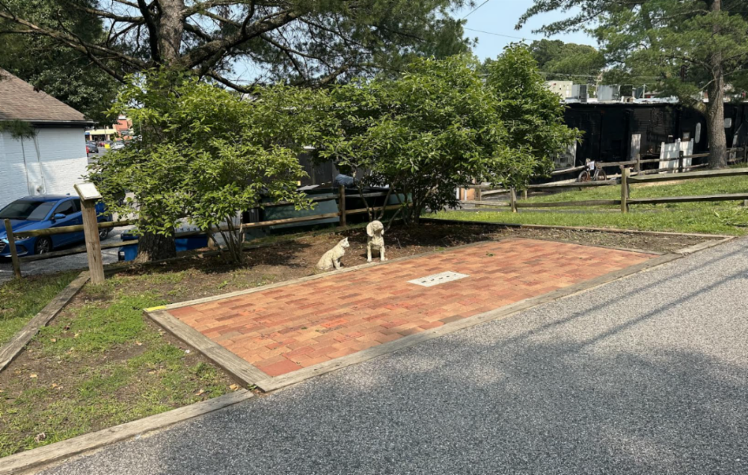

Overhauling a neglected flowerbed is a perfect way to make an instant and lasting impact on the trail! As a flowerbed volunteer, you are responsible for doing a spring clean up, caring for the flowerbed at least once per month during the growing season, and preparing the flowerbed for the winter season. To adopt one of these flowerbeds-in-need, email friendsofaatrails@gmail.com!

Editor's Corner
by Miranda Yourick

  Fireflies Need Our Help to Light Up the Night!
  Fireflies - or wait, maybe you call them lightning bugs? - are synonymous with summer evenings. Even as an adult, I feel a rush of excitement upon seeing the first yellow flashes appear in the treetops. Fireflies use a chemical reaction inside their abdomens to create light, which they flash in sequences that are species-specific to attract mates.
  And no, you aren't going crazy... there really are fewer fireflies than when we were kids. Populations of these dazzling, bioluminescent little bugs are declining. Why? The usual suspects are to blame - widespread pesticide use, habitat loss, and light pollution.
  I don't want to live in a world without fireflies. In fact, I don't want anyone to live in a world without fireflies! It's up to us to ensure future generations can look out on the same sparkling nights that we do.
  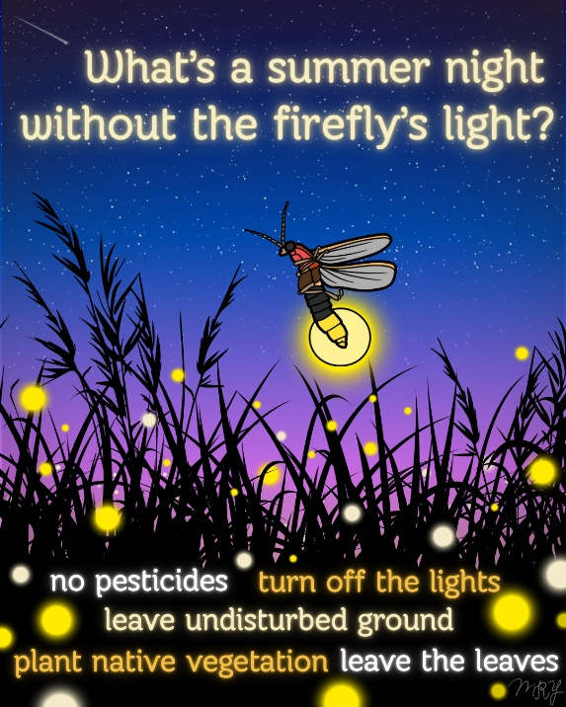
  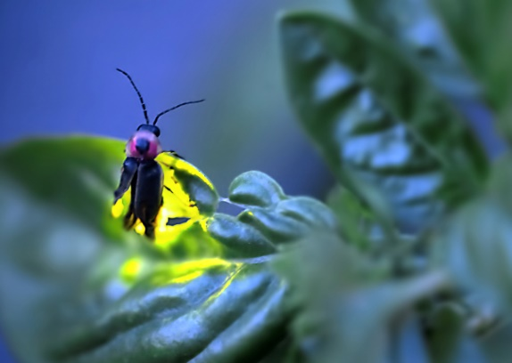
  How YOU can help!
  -Don't use pesticides (none are safe for fireflies!)
  -Don't throw out the leaves! Instead, leave them be or rake them into garden beds to provide places for baby fireflies to develop. It's also the best FREE mulch & fertilizer.
  -Turn off outdoor lighting at night. Or use motion-activated lighting. Fireflies are (obviously) attracted to lights and become confused by artificial lighting.
  -Plant native vegetation of varying heights. Native grasses & sedges are especially good for perching.
  -Leave areas of your gardens undisturbed. Minimize walking on and tilling areas to avoid squishing baby fireflies!
  -Participate in citizen science! Collect fireflies anywhere in MD or DC and send them to USGS scientist Sam Droege at:
  102 Queen Anne Bridge Road, Upper Marlboro, MD 20774.
  1) Collect in Ziploc bag
  2) Label with date, location, habitat, & your contact information
  3) Freeze
  4) Mail (no padding needed)
  In order to save fireflies, we need to monitor and study them!
  Learn more about firefly conservation here!

Support the Friends!!

  Household annual memberships are only $30 and help us fund projects & events on the trails.
  ﻿
  Become a member today!
  Click to join!
  Not ready for membership, but would still like to donate?
  Click below to find our Venmo & other ways to donate!﻿
  Click to donate!

Thanks to our Business Members!

  
  

  
  



Have a business? Support us AND get benefits! Become a member!

Contact Us!

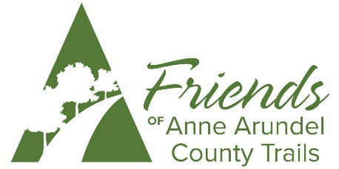

Friends of AA County Trails
P.O. Box 464
Severna Park, MD 21146
friendsofaatrails@gmail.com

Follow us on Facebook for the most up-to-date information on events & news!



